Build a CI/CD Pipeline for Azure Data Factory (Using Azure DevOps) - YouTube
Brayan Ortiz
https://www.youtube.com/watch?v=OkMGYo9BImw

Benefits:
- Can multiple Developers work on the Same ADF Instance
- Can be reverted to the previous version if mistake happens
- Can be easily deployed to ADF available in other environments(i.e from Dev to UAT and Prod)
How to Perform
- Connect Dev ADF instance to a repo which may be a ADF Repo/Github
- Create a build and deploy pipeline
- The build will take the Json file from the DEV instance
- An R Template will be built and it is the artifact
- The deploy pipeline will take this artifact and will deploy in the desired environments

Procedure:
- Set up code Repository and connect to the Repository from ADF and click Apply.
- Note that all the objects that are created in the ADF are represented by JSON Files
- For New Pipeline creation or modification of existing pipeline, create a feature branch out of main branch and get the wok done and create a pull request. It will be approved and moved to the main branch for publish. After publishing from the main branch, the changes will be available in LIVE mode.
- Instead of following the manual process of publishing from the main branch(after approval of the pull request from the feature branch) to the LIVE mode, it can be automated using the pipeline
- Note: Before moving into that Automation part,
  - check that you can disconnect a repository from ADF from linked Service window
  - Connect again to a repository to import into ADF. While doing so, uncheck the following as highlighted below
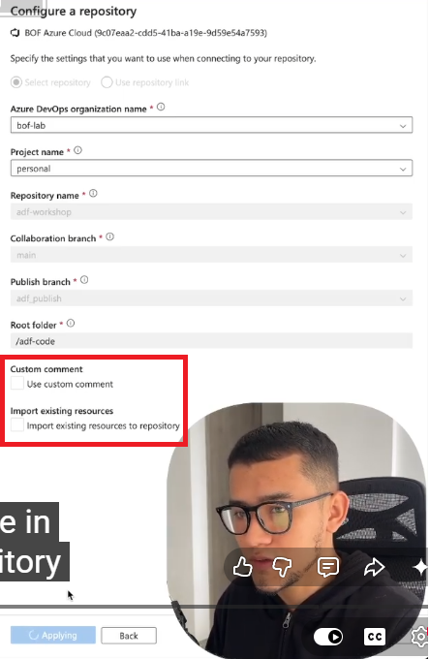

  - In this case, It is not going to override the Code Repository. Because the Code Repository is the Single Source of Truth.

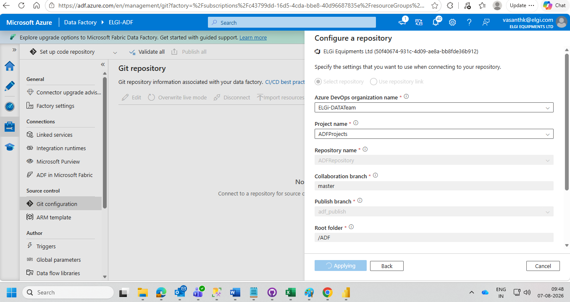

How to Automate the Publish
1. Let us build the Pipeline that builds the Json objects into an R Template.
2. Two YAML Files required for CI and CD. The CI File will be build file and CD file will be the Deploy File
3. To do this, we need a node package called Azure Data Factory Utilities. this is provided by Microsoft.so you only need to create the package.json and put the below code
{
“scripts”:{
“build”:”node node_modules/@microsoft/azure-data-factory-utilities/lib/index”
},
“dependencies”:{
“@microsoft/azure-data-factory-utilities”:”^1.0.0”
}
}

For more information on package.json, Refer page 7

Overview of the Actions to be carried out for build:
- The contents in the ci.yaml file are
  - Trigger for the pipelines
  - Main branch
  - Paths I don’t want this is executed every time I update ADF IAC
  - Pool I am specifying what it is the pool image. Here it is ubuntu
  - Variables
    - adfId it is the azure id of my ADF Instance that I need to provide to the build
    - buildArtifact What’s going to be the build artifact
  - the task consists of installing the node because remember that we have a package and then I install that package.
  - Finally I have two commands which are custom. Those are built in by the package that I provided.
  - So I specify that I want a custom command I say run build validate and I need to specify where the code is and the id of the ADF that I am building
  - The other command is to export those objects. So I do the
    - run build export
    - and specify the location of the code
    - and ADF ID
    - and the name of the artifact to be exported
    - and I am listing those build files
    - and I am publishing those artifacts

Actual Execution of Automation:
- Go to Azure DevOps Pipelines Pipelines
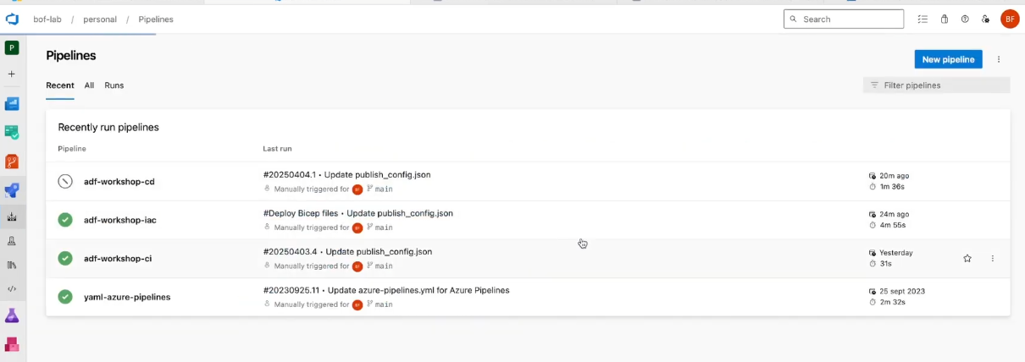

- Open the adf-workshop-ci file
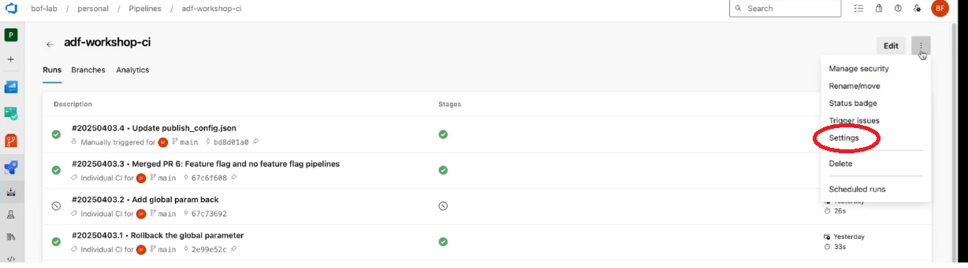

- 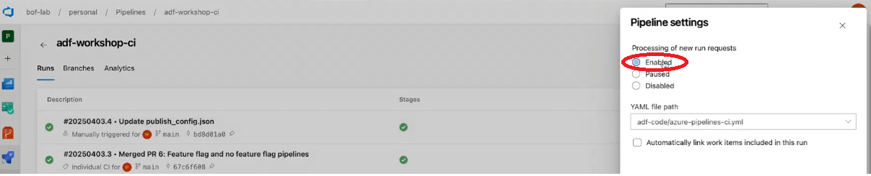

- Then Open the below file

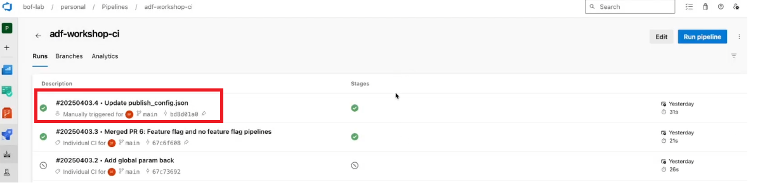

- After opening the file , click on build as shown below

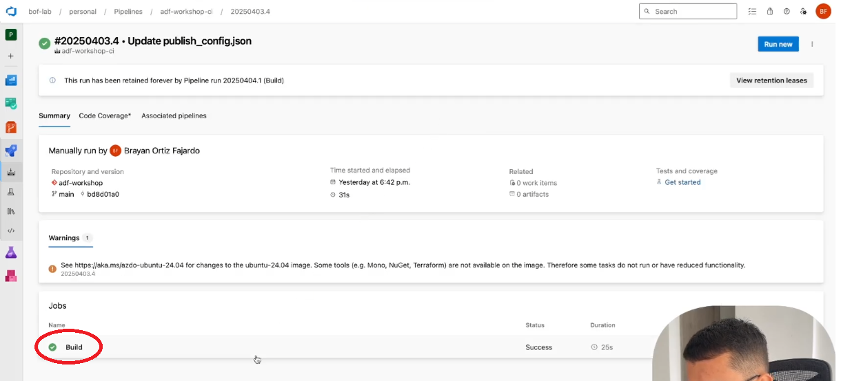

- After opening the build, 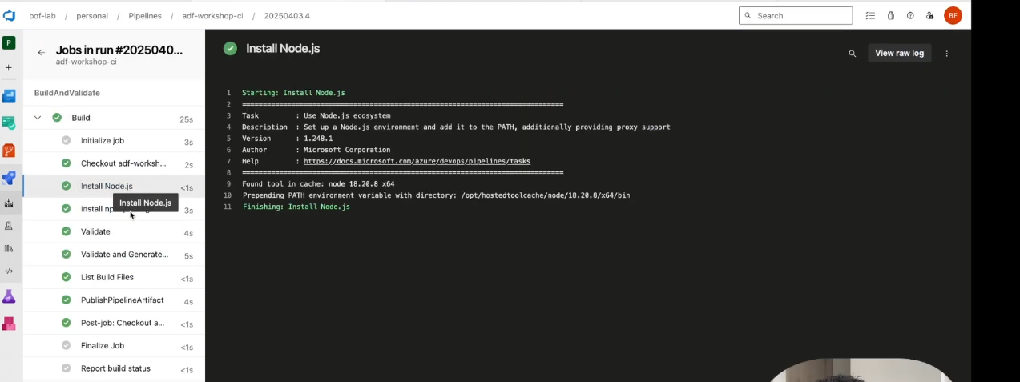

- Artifact will be located as shown below

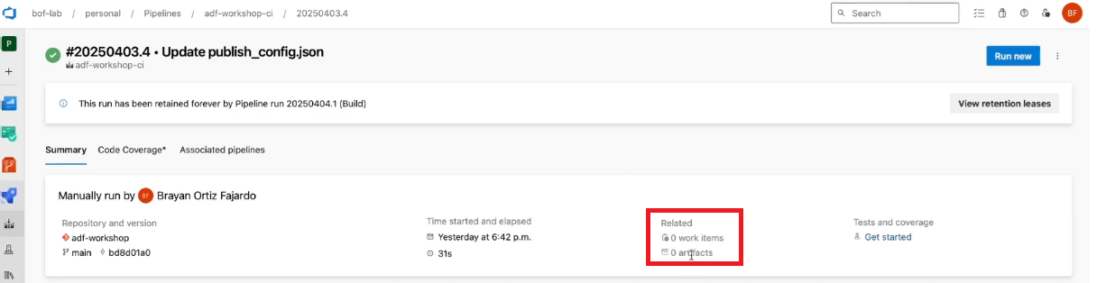

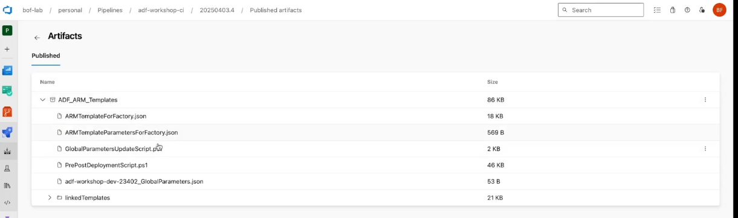

stages:
- stage: BuildAndValidate
jobs:
- job: Build

steps:
- task: UseNode@1
inputs:
version: '18.x'
playName: 'Install Node.js'

- task: Npm@1
inputs:
command: 'install'
#workingDir: '$(Build.Repository.LocalPath)/ADF'
workingDir: $(adfFolder)
verbose: true
displayName: 'Install npm packages'

- task: Npm@1
inputs:
command: 'custom'
#workingDir: '$(Build.Repository.LocalPath)/ADF'
workingDir: $(adfFolder)
customCommand: 'run build validate $(adfFolder) $(adfId)'
displayName: 'Validate'

- task: Npm@1
inputs:
command: 'custom'
#workingDir: '$(Build.Repository.LocalPath)/ADF'
workingDir: $(adfFolder)
customCommand: 'run build export $(adfFolder) $(adfId) $(buildArtifact)'
displayName: 'Validate and Generate ARM Template'

- script: 'ls -r $(adfFolder)'
displayName: 'List all the Build Files'

- task: PublishpipelineArtifact@1
inputs:
targetpath: $(adfFolder)/$(buildArtifact)
artifact: $(buildArtifact)
publishLocation: 'pipeline'

Ref from Chat GPT

package.json
package.json is the Node.js project configuration file. In an Azure Data Factory (ADF) CI pipeline, it tells npm which packages to install and which commands (scripts) are available.
For ADF CI/CD, Microsoft recommends using the Azure Data Factory Utilities package.
Example package.json
{
"name": "adf-cicd",
"version": "1.0.0",
"description": "Azure Data Factory CI/CD",
"private": true,
"scripts": {
"build": "node node_modules/@microsoft/azure-data-factory-utilities/lib/index"
},
"dependencies": {
"@microsoft/azure-data-factory-utilities": "^1.0.3"
}
}
What each section means
Section | Purpose
name | Project name. Can be any meaningful name.
version | Version of your Node.js project.
private | Prevents accidental publishing to npm.
scripts | Defines commands you can run with npm run.
dependencies | Lists packages that npm install downloads.

How it works with your pipeline
When your Azure DevOps pipeline runs:
- script: |
npm install
workingDirectory: adf
npm install:
- Reads package.json.
- Downloads @microsoft/azure-data-factory-utilities into the node_modules folder.
Later, when the pipeline runs:
- script: |
npm run build validate $(Build.SourcesDirectory)/adf \
/subscriptions/$(subscriptionId)/resourceGroups/$(resourceGroup)/providers/Microsoft.DataFactory/factories/$(factoryName)
Here’s what happens:
- npm run build executes the build script from package.json.
- That script starts the ADF Utilities.
- The validate argument tells the utility to validate your ADF artifacts.
Similarly:
npm run build export …
runs the same utility with the export command to generate the ARM templates.
Where should package.json be?
A common repository structure is:
Repository
│
├── adf
│ ├── pipeline
│ ├── dataset
│ ├── linkedService
│ ├── trigger
│ ├── factory
│ └── package.json
│
└── azure-pipelines-ci.yml
If your pipeline specifies:
workingDirectory: adf
then package.json should be inside the adf folder.

Do you need to create it manually?
Yes. If your repository doesn't already contain a package.json, create one in the folder where your ADF project is stored before running npm install.
If you're following Microsoft's latest ADF CI/CD guidance, I can also provide the current recommended package.json for the latest version of @microsoft/azure-data-factory-utilities.

azure adf ci.yml
If you're looking for an Azure Data Factory (ADF) CI pipeline YAML for Azure DevOps, here's a common example that validates and publishes ADF ARM templates.
trigger:
branches:
include:
- main

pool:
vmImage: 'ubuntu-latest'

variables:
nodeVersion: '18.x'
adfPath: 'adf'

steps:
- task: NodeTool@0
inputs:
versionSpec: $(nodeVersion)
displayName: 'Install Node.js'

- script: |
npm install
workingDirectory: $(adfPath)
displayName: 'Install npm packages'

- script: |
npm run build validate $(Build.SourcesDirectory)/$(adfPath) \
/subscriptions/<subscription-id>/resourceGroups/<resource-group>/providers/Microsoft.DataFactory/factories/<factory-name>
workingDirectory: $(adfPath)
displayName: 'Validate ADF'

- script: |
npm run build export $(Build.SourcesDirectory)/$(adfPath) \
/subscriptions/<subscription-id>/resourceGroups/<resource-group>/providers/Microsoft.DataFactory/factories/<factory-name> "ArmTemplate"
workingDirectory: $(adfPath)
displayName: 'Generate ARM Templates'

- task: PublishBuildArtifacts@1
inputs:
PathtoPublish: '$(adfPath)/ArmTemplate'
ArtifactName: 'ArmTemplates'
publishLocation: 'Container'

If you're using the official ADF utilities (@microsoft/azure-data-factory-utilities)
Your package.json typically contains:
{
"scripts": {
"build": "node node_modules/@microsoft/azure-data-factory-utilities/lib/index"
},
"dependencies": {
"@microsoft/azure-data-factory-utilities": "^1.x.x"
}
}
Then the YAML validation step becomes:
- script: |
npm install
npm run build validate $(Build.SourcesDirectory)/adf \
/subscriptions/xxxx/resourceGroups/rg-dev/providers/Microsoft.DataFactory/factories/adf-dev
displayName: Validate ADF
and the export step:
- script: |
npm run build export $(Build.SourcesDirectory)/adf \
/subscriptions/xxxx/resourceGroups/rg-dev/providers/Microsoft.DataFactory/factories/adf-dev \
ArmTemplate
displayName: Export ARM Templates

Typical CI/CD structure
Repo
│
├── adf/
│ ├── pipeline/
│ ├── dataset/
│ ├── linkedService/
│ ├── trigger/
│ └── package.json
│
├── azure-pipelines-ci.yml
└── azure-pipelines-cd.yml
The CI pipeline:
- Validates the ADF JSON.
- Exports ARM templates.
- Publishes the ARM templates as a build artifact.
The CD pipeline:
- Downloads the artifact.
- Deploys the ARM templates to Test/UAT/Production using an ARM or Bicep deployment task.
- Stops and restarts ADF triggers before and after deployment.
If your goal is a complete Azure DevOps CI/CD setup, I can also provide a production-ready pair of azure-pipelines-ci.yml and azure-pipelines-cd.yml files with parameterization for Dev, Test, and Prod environments.

Below is a production-ready Azure DevOps CI/CD setup for Azure Data Factory using the official ADF utilities.

Repository Structure
ADFRepo/
│
├── adf/
│ ├── pipeline/
│ ├── dataset/
│ ├── linkedService/
│ ├── trigger/
│ ├── factory/
│ └── package.json
│
├── azure-pipelines-ci.yml
└── azure-pipelines-cd.yml

package.json
Create this inside the adf folder.
{
"name": "adf-cicd",
"version": "1.0.0",
"scripts": {
"build": "node node_modules/@microsoft/azure-data-factory-utilities/lib/index"
},
"dependencies": {
"@microsoft/azure-data-factory-utilities": "^1.0.3"
}
}

azure-pipelines-ci.yml
trigger:
branches:
include:
- main

pool:
vmImage: ubuntu-latest

variables:
nodeVersion: '18.x'
adfFolder: 'adf'

subscriptionId: '<subscription-id>'
resourceGroup: 'rg-adf-dev'
factoryName: 'adf-dev'

steps:

- checkout: self

- task: NodeTool@0
displayName: Install Node
inputs:
versionSpec: $(nodeVersion)

- script: |
npm install
displayName: Install npm packages
workingDirectory: $(adfFolder)

- script: |
npm run build validate $(Build.SourcesDirectory)/$(adfFolder) \
/subscriptions/$(subscriptionId)/resourceGroups/$(resourceGroup)/providers/Microsoft.DataFactory/factories/$(factoryName)
displayName: Validate ADF
workingDirectory: $(adfFolder)

- script: |
npm run build export $(Build.SourcesDirectory)/$(adfFolder) \
/subscriptions/$(subscriptionId)/resourceGroups/$(resourceGroup)/providers/Microsoft.DataFactory/factories/$(factoryName) \
ArmTemplate
displayName: Generate ARM Templates
workingDirectory: $(adfFolder)

- task: PublishBuildArtifacts@1
displayName: Publish ARM Templates
inputs:
PathtoPublish: '$(adfFolder)/ArmTemplate'
ArtifactName: ADFTemplates

Here's a line-by-line explanation of a typical Azure Data Factory CI pipeline in Azure DevOps.

Complete azure-pipelines-ci.yml

trigger:

branches:

include:

- main

What it does

This tells Azure DevOps when to start the pipeline.

Whenever code is pushed to the main branch, the pipeline runs automatically.

If you want it to run on another branch:

trigger:

branches:

include:

- develop

or multiple branches:

trigger:

branches:

include:

- main

- develop

Build Agent

pool:

vmImage: ubuntu-latest

Azure DevOps creates a temporary virtual machine to run your pipeline.

Common choices:

ubuntu-latest

windows-latest

macos-latest

For ADF, ubuntu-latest is commonly used.

Variables

variables:

nodeVersion: '18.x'

adfFolder: 'adf'

subscriptionId: 'xxxxxxxx-xxxx-xxxx-xxxx-xxxxxxxxxxxx'

resourceGroup: 'rg-adf-dev'

factoryName: 'adf-dev'

Instead of hardcoding values throughout the pipeline, define them once as variables.

For example:

$(factoryName)

becomes

adf-dev

Step 1 – Checkout the Repository

steps:

- checkout: self

This downloads your repository to the build agent.

Suppose your repository looks like this:

Repository

│

├── adf

│ ├── pipeline

│ ├── dataset

│ ├── linkedService

│ └── package.json

│

└── azure-pipelines-ci.yml

The adf folder is now available on the agent.

Step 2 – Install Node.js

- task: NodeTool@0

displayName: Install Node.js

inputs:

versionSpec: $(nodeVersion)

ADF Utilities are written in Node.js.

This installs Node 18.x.

Without Node, commands like:

npm install

npm run build validate

won't work.

Step 3 – Install Packages

- script: |

npm install

workingDirectory: $(adfFolder)

displayName: Install npm packages

This executes:

cd adf

npm install

It downloads the package listed in your package.json.

Example:

{

"dependencies": {

"@microsoft/azure-data-factory-utilities": "^1.0.3"

}

}

Step 4 – Validate ADF

- script: |

npm run build validate \

$(Build.SourcesDirectory)/$(adfFolder) \

/subscriptions/$(subscriptionId)/resourceGroups/$(resourceGroup)/providers/Microsoft.DataFactory/factories/$(factoryName)

workingDirectory: $(adfFolder)

displayName: Validate ADF

This checks that your ADF assets are valid.

It verifies things such as:
- pipeline JSON
- datasets
- linked services
- triggers
- activities
- dependencies

If validation fails, the pipeline stops here.

Step 5 – Export ARM Template

- script: |

npm run build export \

$(Build.SourcesDirectory)/$(adfFolder) \

/subscriptions/$(subscriptionId)/resourceGroups/$(resourceGroup)/providers/Microsoft.DataFactory/factories/$(factoryName) \

ArmTemplate

workingDirectory: $(adfFolder)

displayName: Export ARM Template

This generates ARM deployment files.

Output:

ArmTemplate

│

├── ARMTemplateForFactory.json

└── ARMTemplateParametersForFactory.json

These files are used later by the CD pipeline.

Step 6 – Publish Build Artifact

- task: PublishBuildArtifacts@1

inputs:

PathtoPublish: 'adf/ArmTemplate'

ArtifactName: 'ADFTemplates'

This uploads the ARM templates as a pipeline artifact.

The CD pipeline downloads these artifacts and deploys them.

Overall Flow

Developer

│

▼

Git Push

│

▼

Azure DevOps

│

▼

Checkout Repository

│

▼

Install Node.js

│

▼

npm install

│

▼

Validate ADF

│

▼

Generate ARM Template

│

▼

Publish Artifact

What happens next?

The CD pipeline:
- Downloads the ADFTemplates artifact.
- Stops ADF triggers (optional but recommended).
- Deploys the ARM template to the target environment (Test/Prod).
- Restarts the triggers.

This completes the CI/CD process.

If you're using the modern Git-based Azure Data Factory workflow (where the adf_publish branch is no longer used), the CI/CD setup differs slightly. I can show that approach as well if that's the workflow you're using.

Why is Node.js needed for ADF?

Azure Data Factory CI pipelines use the ADF Utilities package (@microsoft/azure-data-factory-utilities), which is a Node.js application. Commands such as:

npm install

npm run build validate

npm run build export

require Node.js to be installed first.

azure-pipelines-cd.yml
trigger: none

resources:
pipelines:
- pipeline: ADFBuild
source: ADF-CI
trigger: true

pool:
vmImage: ubuntu-latest

variables:

azureServiceConnection: 'Azure-Service-Connection'

resourceGroup: 'rg-adf-test'

factoryName: 'adf-test'

steps:

- download: ADFBuild
artifact: ADFTemplates

- task: AzureResourceManagerTemplateDeployment@3
displayName: Deploy ARM Template

inputs:
deploymentScope: Resource Group

azureResourceManagerConnection: $(azureServiceConnection)

subscriptionId: '<subscription-id>'

action: Create Or Update Resource Group

resourceGroupName: $(resourceGroup)

location: East US

templateLocation: Linked artifact

csmFile: $(Pipeline.Workspace)/ADFBuild/ADFTemplates/ARMTemplateForFactory.json

csmParametersFile: $(Pipeline.Workspace)/ADFBuild/ADFTemplates/ARMTemplateParametersForFactory.json

deploymentMode: Incremental

Multi-environment deployment
Use stages for Dev → Test → Prod.
Build
│
▼
Publish ARM Template
│
▼
Deploy DEV
│
▼
Approval
│
▼
Deploy TEST
│
▼
Approval
│
▼
Deploy PROD

Recommended Variable Groups
Create one variable group per environment.
Variable | Dev | Test | Prod
ResourceGroup | rg-adf-dev | rg-adf-test | rg-adf-prod
FactoryName | adf-dev | adf-test | adf-prod
SubscriptionId | xxx | xxx | xxx
Location | East US | East US | East US

Best Practices
- Store secrets in Azure Key Vault rather than in the repository.
- Use a separate service connection for each environment when appropriate.
- Stop ADF triggers before deployment and restart them afterward to avoid runs during deployment.
- Use Incremental deployment mode to avoid deleting resources unintentionally.
- Protect the main branch with pull request validation.
This setup follows Microsoft's recommended CI/CD approach for Azure Data Factory and is suitable for promoting changes through Dev, Test, and Production environments.

the above ci.yaml ran successfully... what to do next
Great. Since your ADF CI pipeline completed successfully, your CI process is working:
✅ Checkout ADF code
✅ Install Node.js
✅ Install ADF Utilities
✅ Validate ADF artifacts
✅ Generate ARM templates
✅ Publish ARM template artifact
The next step is to create the CD (Continuous Deployment) pipeline to deploy your ADF changes to another environment (for example, Test/UAT/Production).

Step 1: Verify the CI artifact
Go to:
Azure DevOps → Pipelines → Your CI Pipeline → Latest Run
Open the run and check:
Artifacts
You should see something like:
ADF_ARM_Templates
│
├── ARMTemplateForFactory.json
└── ARMTemplateParametersForFactory.json
If this exists, your CI output is ready for deployment.

Step 2: Create a CD pipeline YAML
Create a new file in your repository:
azure-pipelines-cd.yml
Example:
trigger: none

pool:
vmImage: ubuntu-latest

variables:
resourceGroup: '<TargetResourceGroup>'
factoryName: '<TargetADFName>'

stages:

- stage: DeployADF
displayName: Deploy ADF

jobs:

- deployment: Deploy
displayName: Deploy ARM Template
environment: 'ADF-UAT'

strategy:
runOnce:
deploy:

steps:

- download: current
artifact: ADF_ARM_Templates

- task: AzureResourceManagerTemplateDeployment@3
displayName: Deploy ADF ARM Template

inputs:
deploymentScope: Resource Group

azureResourceManagerConnection: '<ServiceConnectionName>'

subscriptionId: '<subscriptionId>'

action: Create Or Update Resource Group

resourceGroupName: '<TargetResourceGroup>'

location: 'Central India'

templateLocation: Linked artifact

csmFile: '$(Pipeline.Workspace)/ADF_ARM_Templates/ARMTemplateForFactory.json'

csmParametersFile: '$(Pipeline.Workspace)/ADF_ARM_Templates/ARMTemplateParametersForFactory.json'

overrideParameters: >
-factoryName "$(factoryName)"

Step 3: Create Azure Service Connection
Before running CD:
Go to:
Azure DevOps
→ Project Settings
→ Service connections
→ New service connection
→ Azure Resource Manager
Choose:
Service principal (automatic)
Select:
- Subscription
- Resource Group (optional)
- Name:
Example:
ADF-Deployment-ServiceConnection
Then use this name in:
azureResourceManagerConnection:

Step 4: Create deployment environments
Go to:
Pipelines
→ Environments
→ New Environment
Create:
ADF-UAT
This gives you approvals and deployment history.

Step 5: Test deployment
Run the CD pipeline manually.
Expected flow:
CI Pipeline
|
|
v
ADF_ARM_Templates Artifact
|
|
v
CD Pipeline
|
|
v
ARM Deployment
|
|
v
Azure Data Factory UAT

Recommended ADF promotion flow
A common enterprise setup:
Developer
|
v
ADF Dev Factory
|
v
Git master branch
|
v
CI Pipeline
|
v
ARM Template
|
v
UAT ADF
|
v
Approval
|
v
Production ADF

Before creating your CD YAML, one important question:
Do you have separate ADF environments already (Dev → UAT → Prod), or are you deploying from Git directly to the same Data Factory?
The CD YAML changes slightly depending on your setup.
If you're deploying back to the same Azure Data Factory, you generally don't need a CD pipeline. In this setup:
- Developers commit changes to Git.
- The CI pipeline validates the code and generates ARM templates.
- Publishing from ADF Studio (or using the generated templates) updates the same Data Factory.
A separate CD pipeline is most useful when deploying to another Data Factory (such as UAT or Production).
That said, if your goal is to automate deployment back to the same Data Factory after CI, you can use a CD pipeline like the one below.
trigger: none

pool:
vmImage: 'ubuntu-latest'

variables:
azureServiceConnection: '<Your-Service-Connection>'
subscriptionId: '<Subscription-ID>'
resourceGroup: '<Resource-Group>'
factoryName: '<ADF-Name>'

steps:

- download: current
artifact: ADF_ARM_Templates

- task: AzureResourceManagerTemplateDeployment@3
displayName: 'Deploy ARM Template'

inputs:
deploymentScope: 'Resource Group'
azureResourceManagerConnection: '$(azureServiceConnection)'
subscriptionId: '$(subscriptionId)'
action: 'Create Or Update Resource Group'
resourceGroupName: '$(resourceGroup)'
location: '<Azure-Region>'
templateLocation: 'Linked artifact'
csmFile: '$(Pipeline.Workspace)/ADF_ARM_Templates/ARMTemplateForFactory.json'
csmParametersFile: '$(Pipeline.Workspace)/ADF_ARM_Templates/ARMTemplateParametersForFactory.json'
overrideParameters: >
-factoryName $(factoryName)
deploymentMode: 'Incremental'

Before using this pipeline
Replace these placeholders:
- <Your-Service-Connection> → Your Azure Resource Manager service connection in Azure DevOps.
- <Subscription-ID> → Your Azure subscription ID.
- <Resource-Group> → The resource group containing your Data Factory.
- <ADF-Name> → Your Data Factory name.
- <Azure-Region> → For example, Central India, East US, or West Europe.

Important consideration
If you're deploying to the same Data Factory that your developers are actively editing in Git mode, automated deployment can overwrite changes or create conflicts. Many teams using a single Data Factory simply:
- Develop in Git mode.
- Run the CI pipeline for validation.
- Use Publish in ADF Studio to update the live factory.
This avoids an extra deployment step.
If your objective is to learn Azure DevOps CI/CD, the CD pipeline above is a good exercise. If your objective is to manage a production ADF, the recommended architecture is to have separate Dev, UAT, and Prod Data Factories and use the CD pipeline to deploy between them.

what is the purpose of YAML File
A YAML file (YAML Ain't Markup Language) is a configuration file that tells a system what to do and in what order. In Azure DevOps, a YAML file defines your CI/CD pipeline as code.
Instead of clicking through the Azure DevOps UI to configure a pipeline, you write the steps in a YAML file. This approach is often called Pipeline as Code.

In your Azure Data Factory (ADF) project
Your azure-pipelines-ci.yml file tells Azure DevOps to:
- Trigger the pipeline when code is pushed to the master branch.
- Use an Ubuntu build agent.
- Install Node.js.
- Install the ADF Utilities package.
- Validate your ADF artifacts.
- Generate ARM templates.
- Publish the ARM templates as a build artifact.
So, when you commit changes to your repository, Azure DevOps automatically performs all those steps without manual intervention.

Think of it like a recipe
Suppose you're baking a cake.
The recipe might be:
- Gather ingredients.
- Preheat the oven.
- Mix the ingredients.
- Bake for 30 minutes.
- Cool and serve.
A YAML pipeline is similar—it lists the steps the build agent should execute.
For example:
steps:
- checkout: self
- task: NodeTool@0
- script: npm install
- script: npm run build validate
- script: npm run build export
Azure DevOps follows these steps one by one.

Why use a YAML pipeline?
- Version-controlled: The pipeline definition is stored in your Git repository alongside your code.
- Repeatable: Every run follows the same process, reducing manual errors.
- Collaborative: Team members can review and update the pipeline through pull requests.
- Automated: Builds and deployments can run automatically on every code change.

In an ADF CI/CD process
Typically, you'll have:
- CI pipeline (azure-pipelines-ci.yml)
  - Validates the ADF code.
  - Generates ARM templates.
  - Publishes build artifacts.
- CD pipeline (azure-pipelines-cd.yml)
  - Downloads the ARM templates.
  - Deploys them to Test, UAT, or Production.
  - Optionally stops and restarts ADF triggers during deployment.

Where does Azure DevOps find the YAML?
When you create a pipeline and select your repository, Azure DevOps looks for a file such as:
azure-pipelines-ci.yml
It reads the file and executes the instructions defined in it.
In short, the YAML file is the blueprint for your automation. It describes exactly how your application or ADF project should be built, validated, tested, and deployed, making the process consistent and repeatable every time the pipeline runs.

what is the purpose of YAML File in general
In general, a YAML file is a human-readable configuration file used to define settings, workflows, or instructions for software. It is widely used because it's easy to read and write compared to formats like XML or JSON.
YAML stands for YAML Ain't Markup Language.

What is it used for?
Instead of hardcoding configuration in application code, developers place it in a YAML file. The application or tool reads the file and acts according to the instructions.
For example, a YAML file might define:
- Application settings
- Build and deployment pipelines
- Infrastructure resources
- Container configurations
- Automation workflows

Example 1: Application configuration
server:
port: 8080

database:
host: db.company.com
port: 5432
username: appuser
An application reads this file to know which server port and database to use.

Example 2: Azure DevOps Pipeline
trigger:
- main

pool:
vmImage: ubuntu-latest

steps:
- script: echo "Hello World"
Azure DevOps reads this file and:
- Runs the pipeline when code is pushed to main.
- Creates an Ubuntu build agent.
- Executes the script.

Example 3: Docker Compose
version: '3'

services:
web:
image: nginx
ports:
- "80:80"
Docker Compose reads this YAML file and starts an Nginx container exposing port 80.

Example 4: Kubernetes
apiVersion: v1
kind: Pod

metadata:
name: myapp

spec:
containers:
- name: app
image: nginx
Kubernetes uses this file to create and manage a pod running an Nginx container.

Why YAML is popular
- Easy to read: Uses indentation instead of lots of brackets or tags.
- Portable: Many tools and platforms support it.
- Version-controlled: Configuration files can be stored in Git alongside code.
- Automatable: Systems can read the file and perform tasks without manual intervention.

YAML vs. JSON
The following two examples represent the same data.
YAML
employee:
name: John
age: 30
JSON
{
"employee": {
"name": "John",
"age": 30
}
}
YAML is often preferred for configuration because it is more concise and easier for people to read.

Common uses of YAML
Tool/Platform | Purpose
Azure DevOps | CI/CD pipeline definitions
GitHub Actions | Workflow automation
Kubernetes | Cluster and application deployment
Docker Compose | Multi-container application configuration
Ansible | Infrastructure automation
Helm | Kubernetes application packaging
Spring Boot | Application configuration (application.yml)

In simple terms
You can think of a YAML file as an instruction manual for software. Rather than telling a person what to do, it tells a program or platform how to behave, what resources to use, and what sequence of actions to perform. This makes systems easier to configure, automate, and maintain without changing the application's source code.

why ARm Templates to be uploaded as a artifact
Uploading ARM templates as a build artifact is a key part of the CI/CD process because it separates the build (CI) stage from the deployment (CD) stage.
Here's why it's done.
1. Preserve the exact output of the CI pipeline
During the CI pipeline, Azure Data Factory Utilities:
- Validate the ADF artifacts.
- Generate ARM templates:
  - ARMTemplateForFactory.json
  - ARMTemplateParametersForFactory.json
These generated files are the deployment package. Publishing them as an artifact preserves exactly what was built and validated.
Source Code
│
▼
CI Pipeline
│
├── Validate ADF
├── Generate ARM Templates
▼
Build Artifact (ARM Templates)

2. Allow the CD pipeline to deploy the same package
The CD pipeline doesn't regenerate the templates. Instead, it downloads the artifact produced by CI and deploys it.
CI Pipeline
│
▼
ADF_ARM_Templates (Artifact)
│
▼
CD Pipeline
│
▼
Deploy to Test/UAT/Production
This ensures you're deploying the exact version that was validated.

3. Ensure consistency across environments
Suppose you have three environments:
- Development
- UAT
- Production
You want all of them to receive the same deployment package.
CI
│
▼
Artifact
├── Deploy to UAT
├── Deploy to QA
└── Deploy to Production
Without artifacts, each deployment might regenerate templates from a different version of the source code, leading to inconsistent deployments.

4. Support approvals and releases
Many organizations require:
- Build approval
- UAT testing
- Production approval
The artifact serves as the approved package that moves through each stage.
Developer
│
▼
Build
│
▼
Artifact
│
▼
UAT Approval
│
▼
Production

5. Enable traceability
Azure DevOps stores build artifacts with each pipeline run.
For example:
Build #101
└── ADF_ARM_Templates

Build #102
└── ADF_ARM_Templates

Build #103
└── ADF_ARM_Templates
If an issue is found in Production, you can identify exactly which artifact was deployed and, if necessary, redeploy a previous one.

In the context of Azure Data Factory
The artifact typically contains files such as:
ADF_ARM_Templates
│
├── ARMTemplateForFactory.json
├── ARMTemplateParametersForFactory.json
└── (other generated deployment files, if applicable)
The CD pipeline downloads these files and uses them to deploy the Data Factory resources.

Why not deploy directly from the source code?
Deploying directly from the source means:
- The code might have changed between validation and deployment.
- Each deployment could generate a slightly different ARM template.
- You lose the guarantee that the deployed package is the one that passed validation.
Publishing the ARM templates as an artifact avoids these risks by making the deployment package immutable for that pipeline run.
In short: the ARM templates are uploaded as a build artifact so they become a versioned, validated, reusable deployment package that can be promoted consistently through Test, UAT, and Production without being regenerated.

